SCHOOL OF COMPUTER SCIENCE AND ARTIFICIAL INTELLIGENCE |  |  |  |  | DEPARTMENT OF COMPUTER SCIENCE ENGINEERING
Program Name: M. Tech/MCA/MSC |  |  |  | Assignment Type: Lab |  |  | AcademicYear:2025-2026
Course Coordinator Name |  |  |  | Venkataramana Veeramsetty
Course Code |  |  |  | Course Title |  | AI Assisted Problem Solving Using Python
AssignmentNumber:14.3(Presentassignmentnumber)/24(Totalnumberofassignments)
 | Q.No. | Question
 | Q1.  Q2.  Q3.  Q4. | Task Description #1 – AI-generated HTML Page  Task: Ask AI to generate a simple HTML homepage for a "Student Info Portal" with a header, navigation menu, and footer.  Expected Output:  - HTML code with <header>, <nav>, <footer>.  - Clean indentation, proper tags, and comments.  Prompt:  #Generate a simple HTML homepage for a “Student Info Portal”.  # Include <header>, <nav>, and <footer>.  # Navigation menu should contain: Home, About, Contact.  # Clean indentation, proper tags, and comments.  # Add a main content section with a welcome message.  CODE:  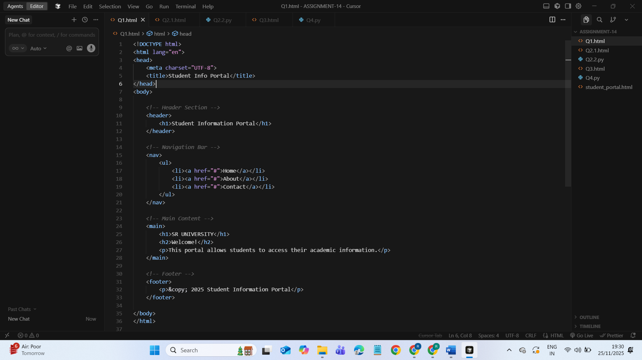  OUTPUT:  Task Description #2 – CSS Styling  Task:  Use AI to add CSS styling to Task #1 homepage for:  - Responsive navigation bar.  - Centered content section.  - Footer with light gray background.  Expected Output:  - HTML + CSS combined.  - AI explains how CSS classes apply.  Expected Output: AI refactors with with open() and try-except:  TASK_SOLUTION 2.1: ADDING CSS STYLE TO ABOVE HTML  PROMPT:  #Add CSS styling to the Student Info Portal page created in Task #1.  #Responsive navigation bar  # Centered content section  # Footer with light gray background  # Combine HTML + CSS  # Explain how CSS classes apply  TASK _SOLUTION 2.2: Refactoring code with open() and try except:  PROMPT:  #Refactor HTML using with open() and try-except to save output to file.  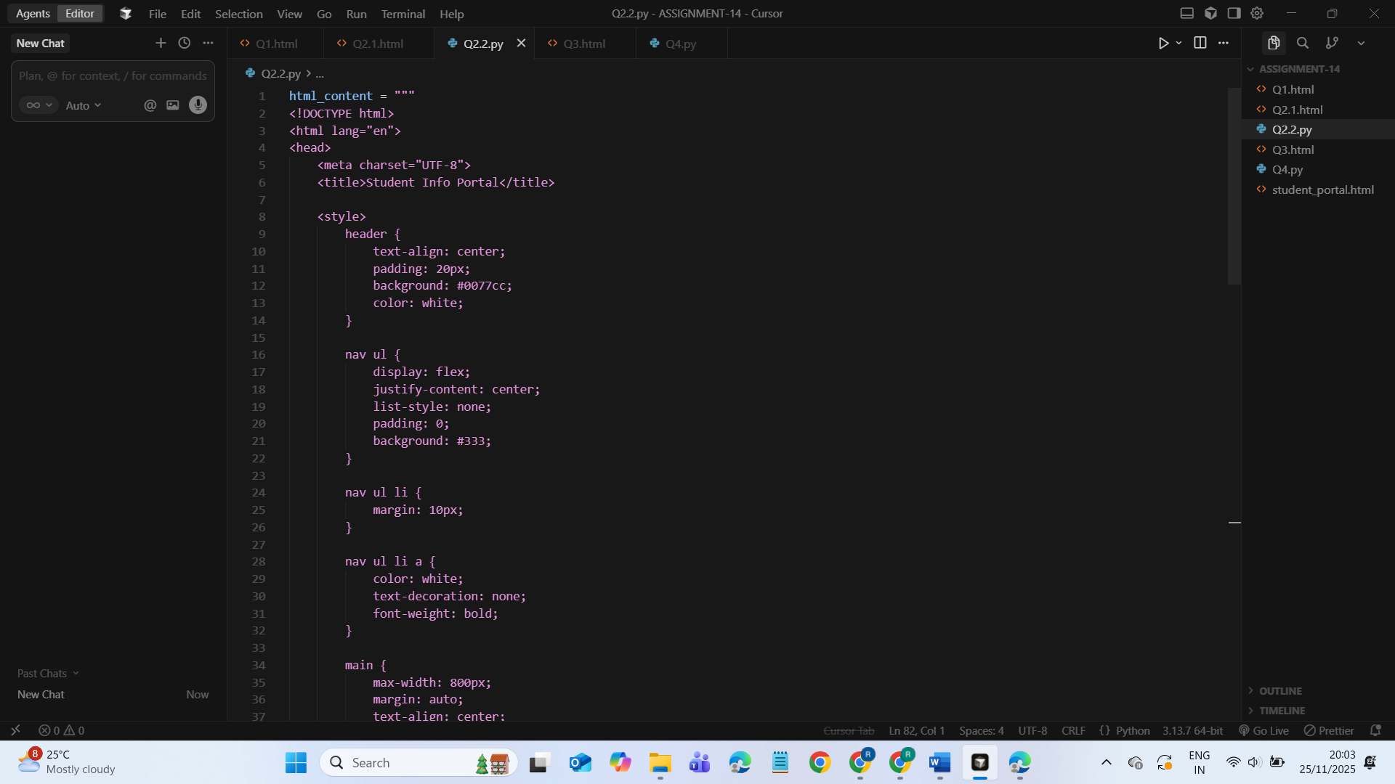  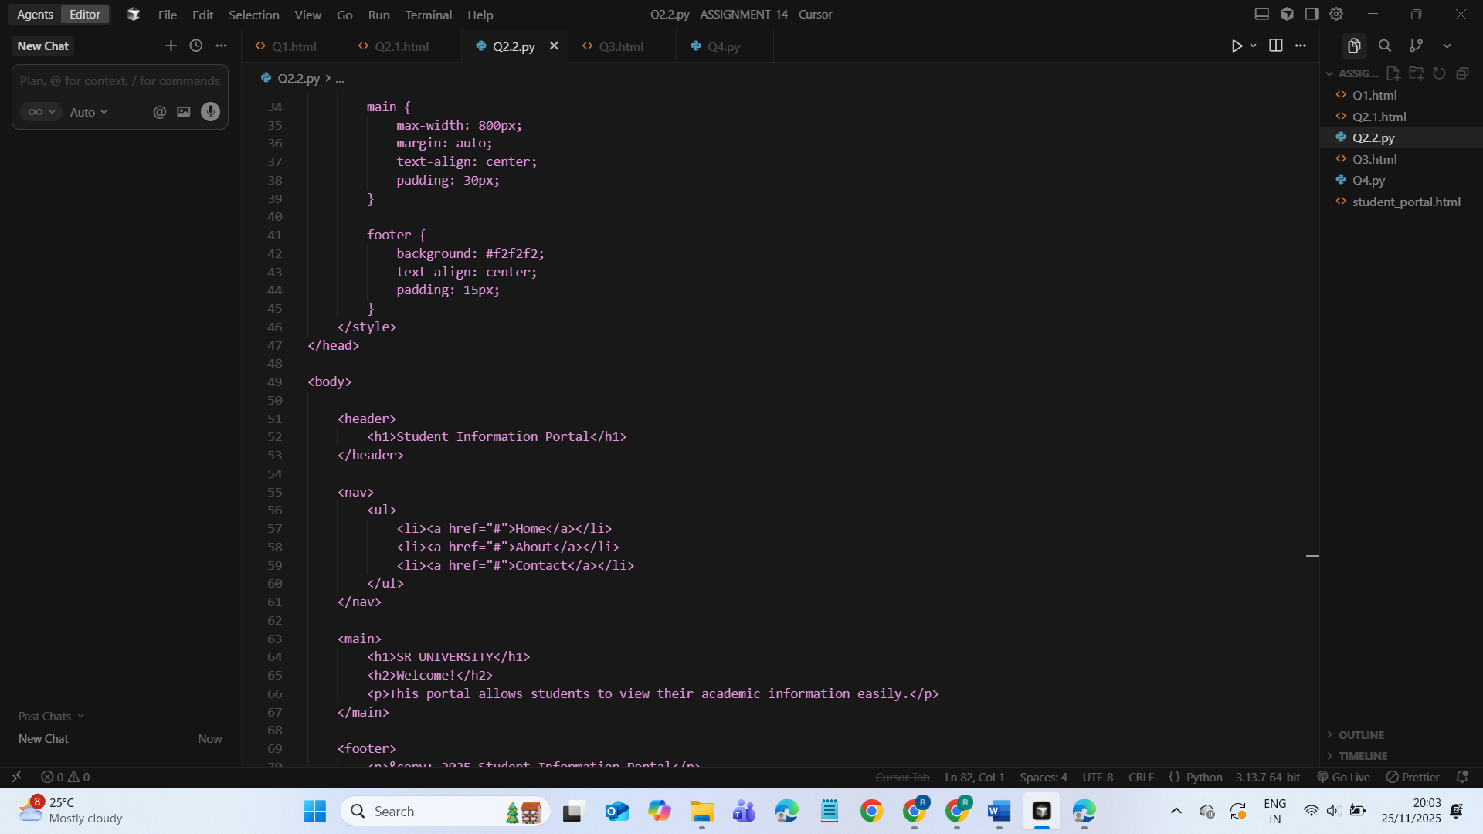  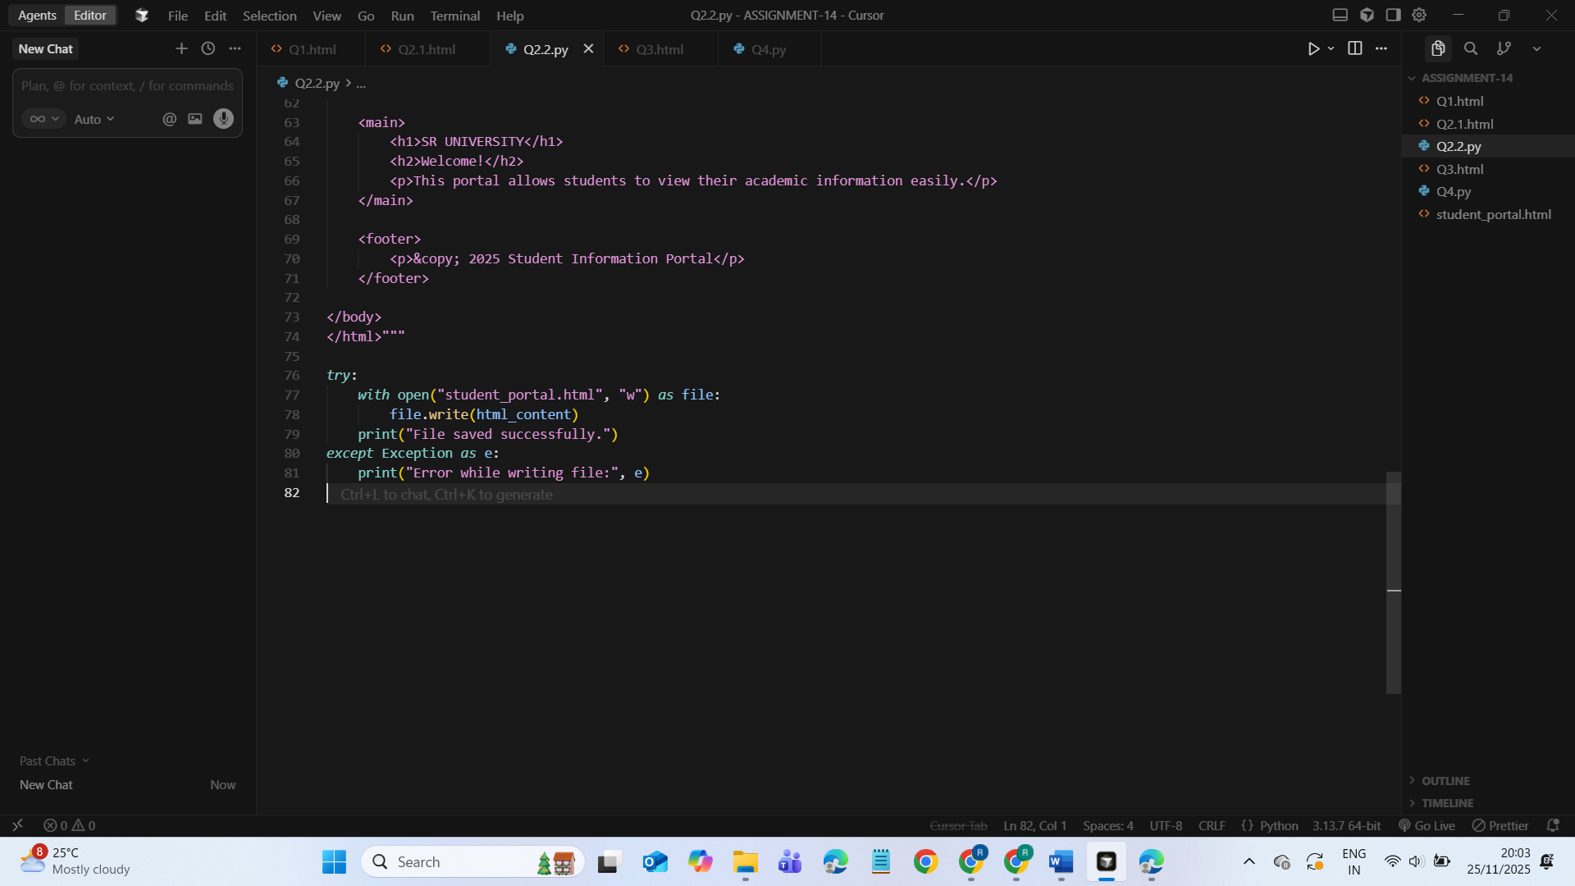  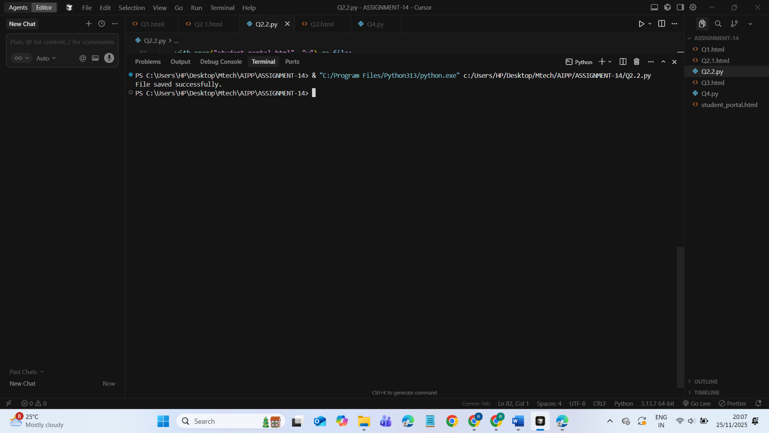  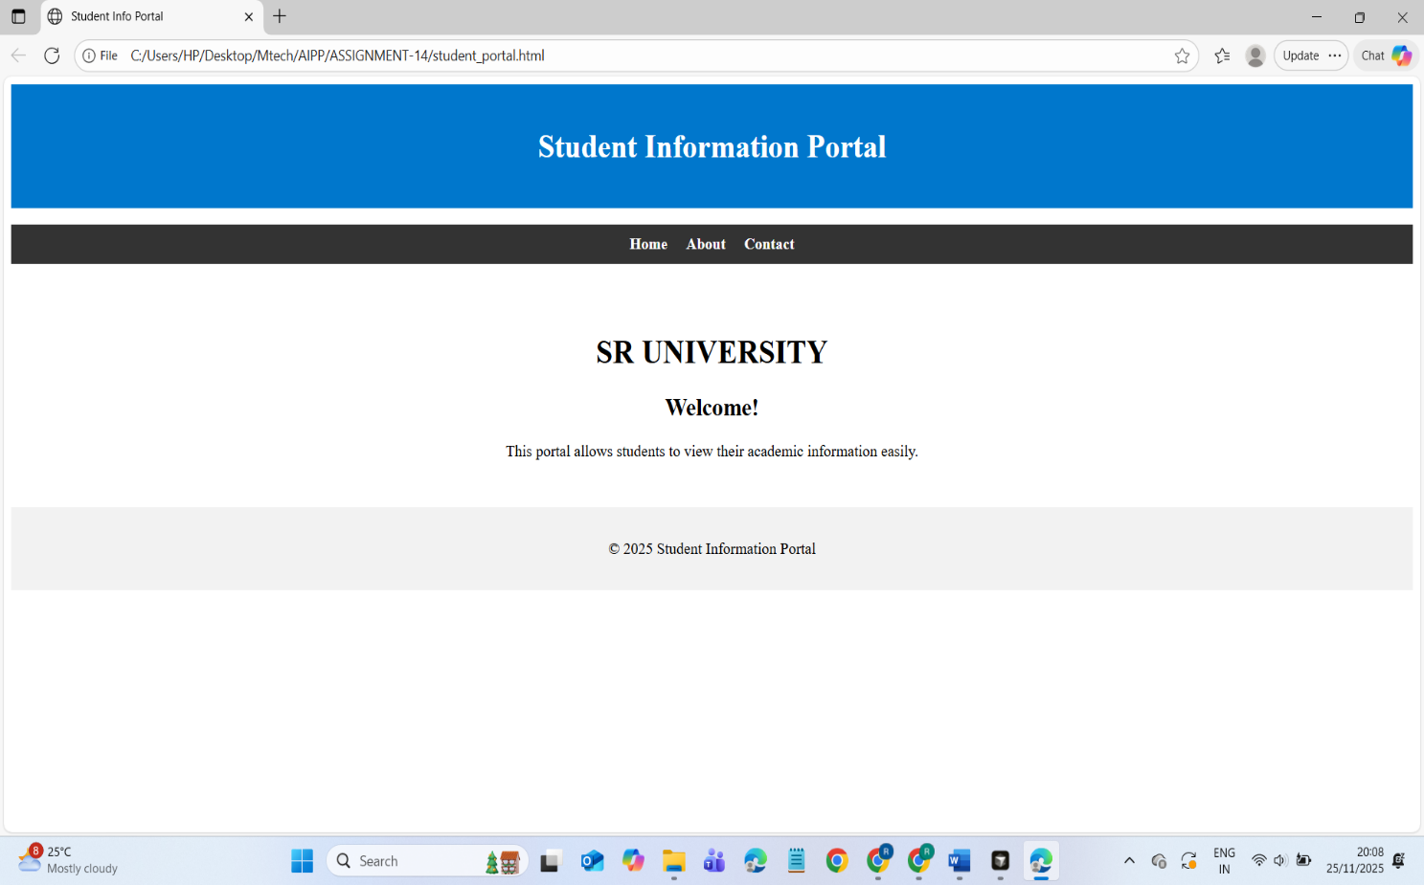  Task Description #3 – JavaScript Interactivity  Task: Prompt AI to generate a JS script that validates a simple login form (non-empty username/password).  Expected Output:  Working on submit JS validation.  Clear error messages if inputs are empty.  PROMPT:  #Generate JavaScript code that validates a login form.  # Username and password must not be empty  # Show clear error messages  #Form should not submit until fields are complete  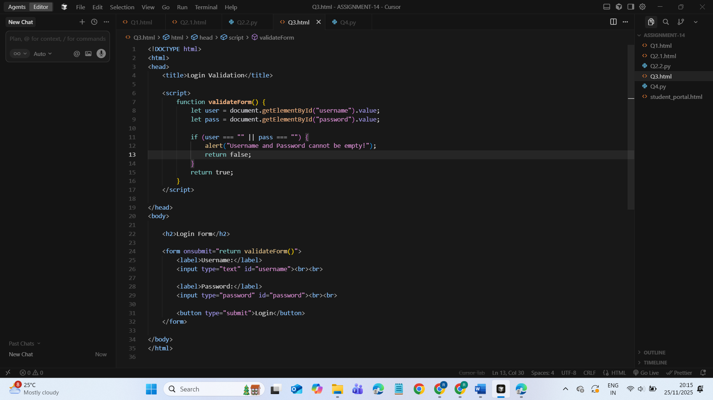  OUTPUT:  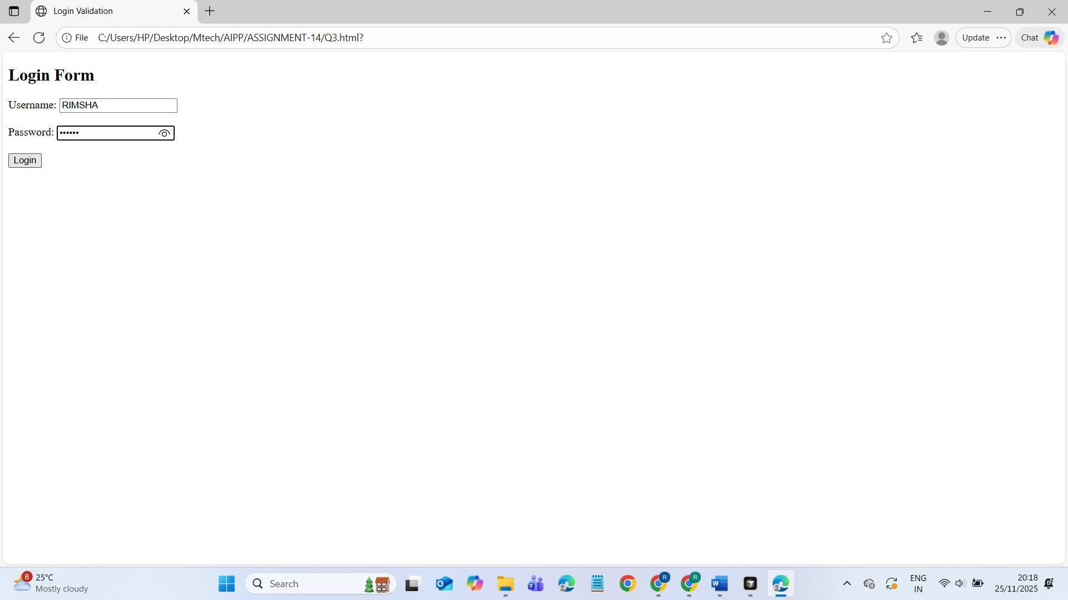  ERROR HANDLING:  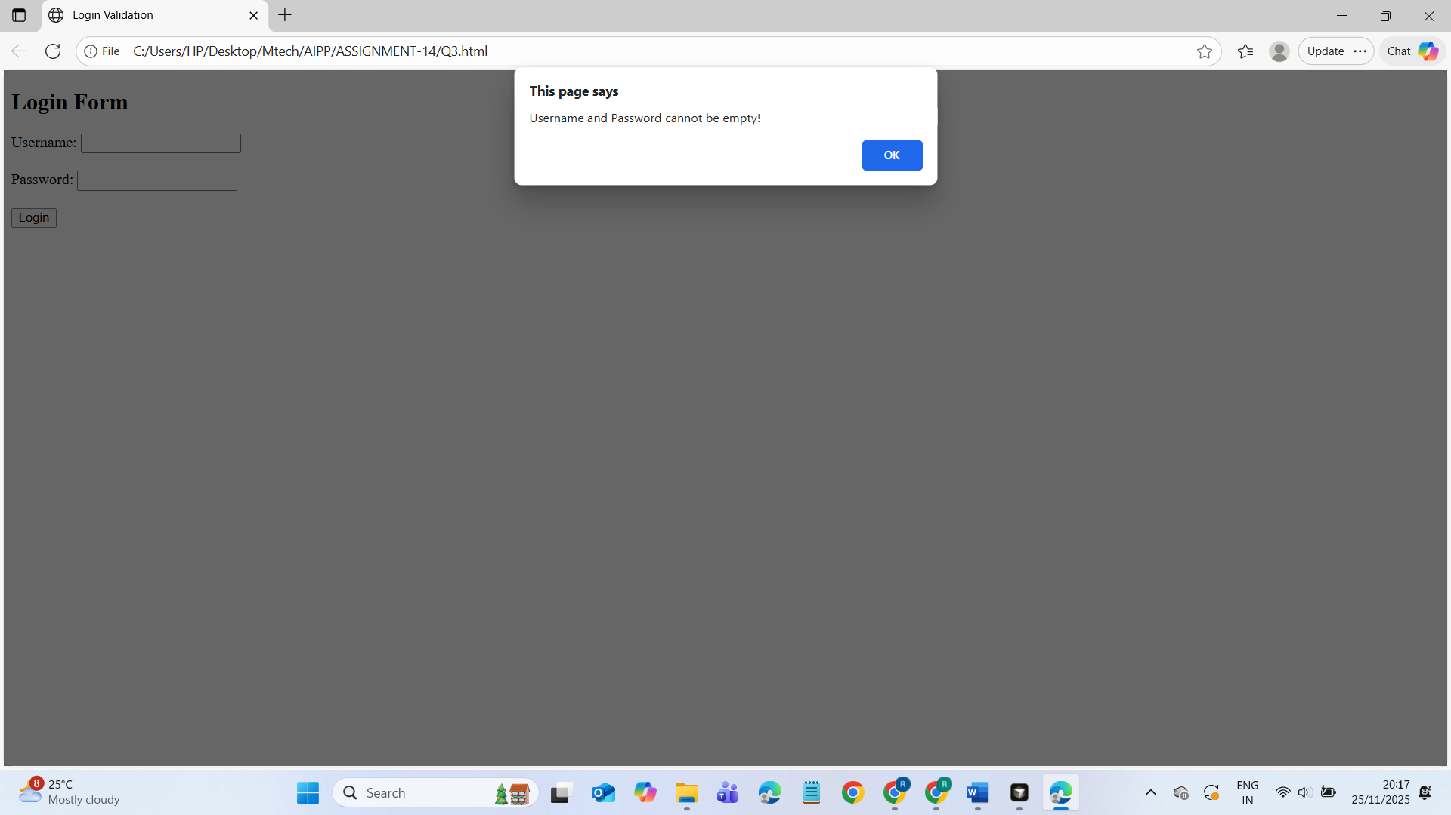Task Description #4 – Python Backend Integration  Task: Ask AI to generate a Flask app that serves the HTML form (Task #3) and prints the username on successful login.  PROMPT:  # Create a Flask backend that serves the HTML login form (from Task 3)  and prints the username on successful login.  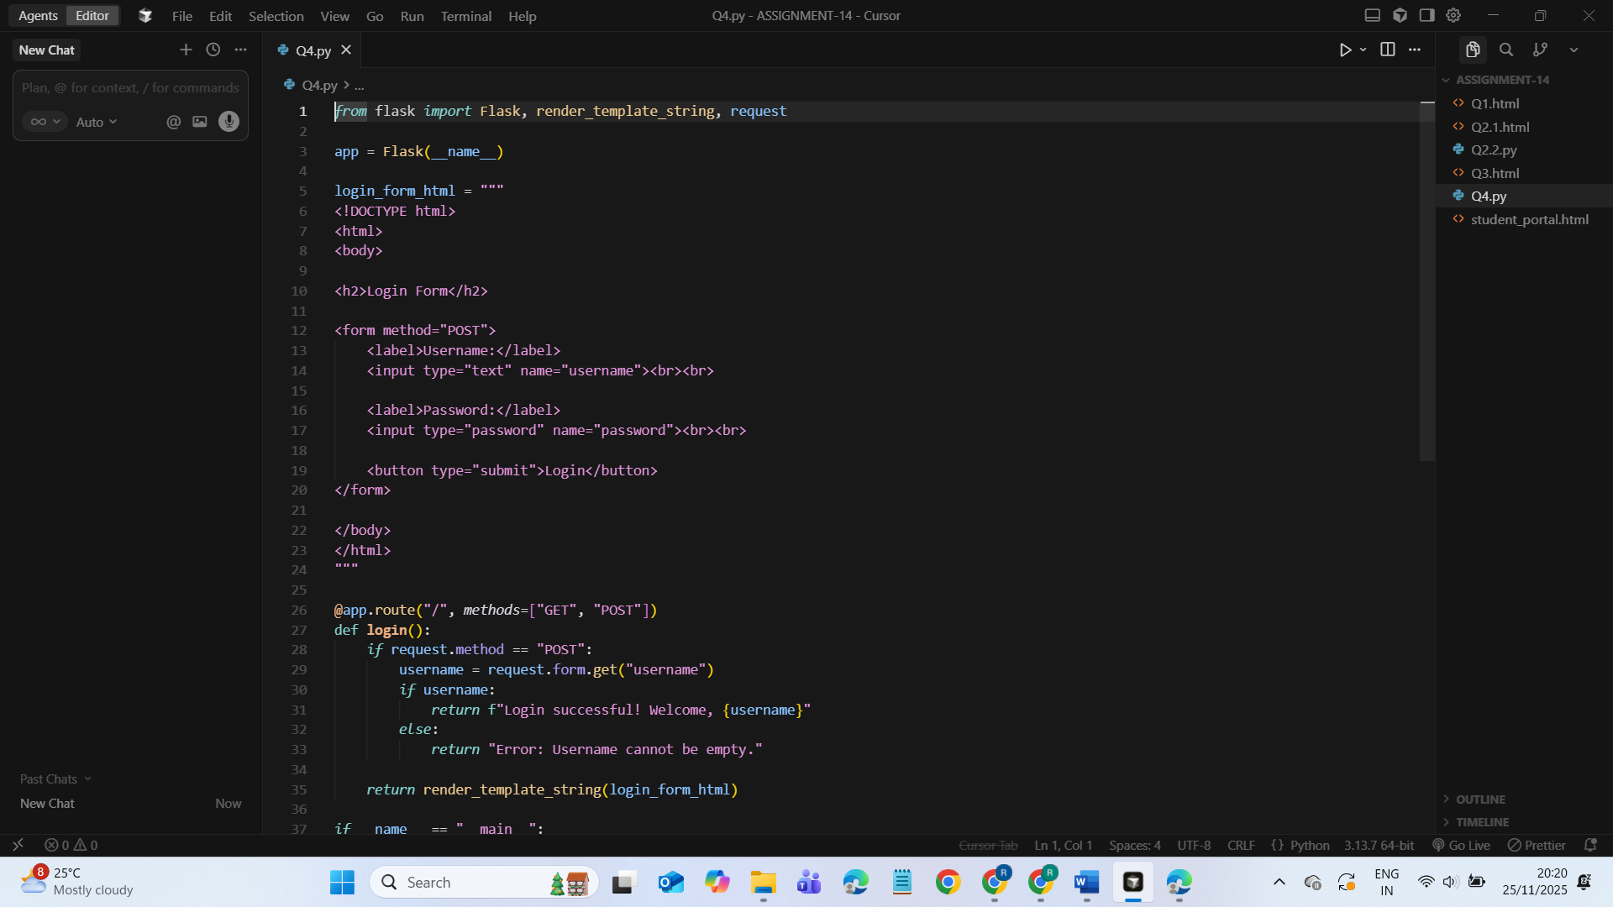  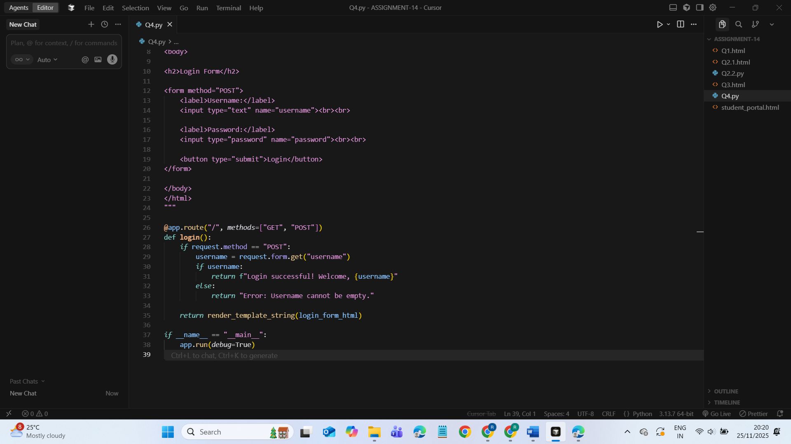  OUTPUT:  